**STUDENTS COLLECTION:**

**Db.Students.insertMany() | db.Students.find()**

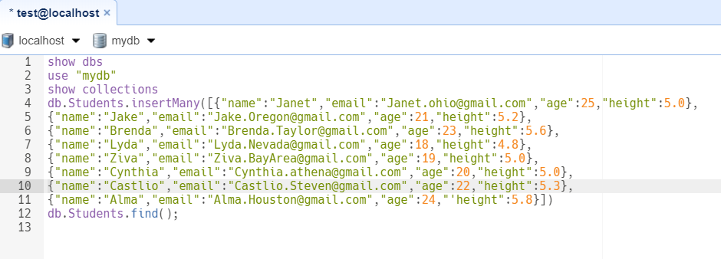

**Result:**

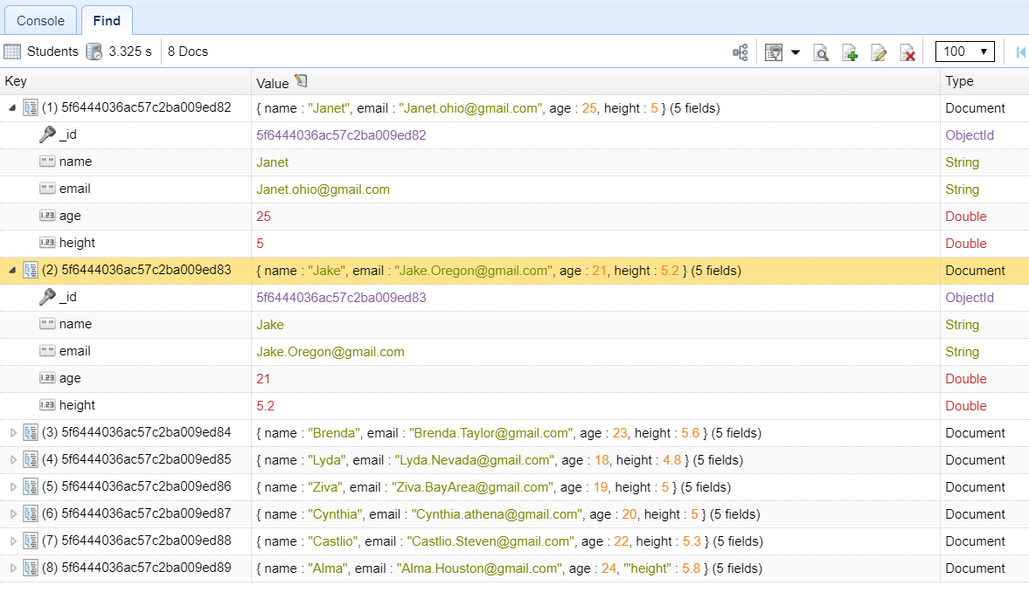

**To find the students age between 21 to 30**

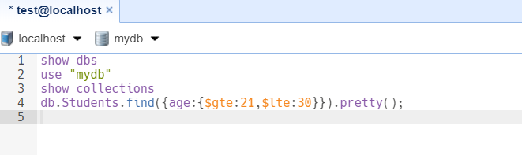

**Result:**

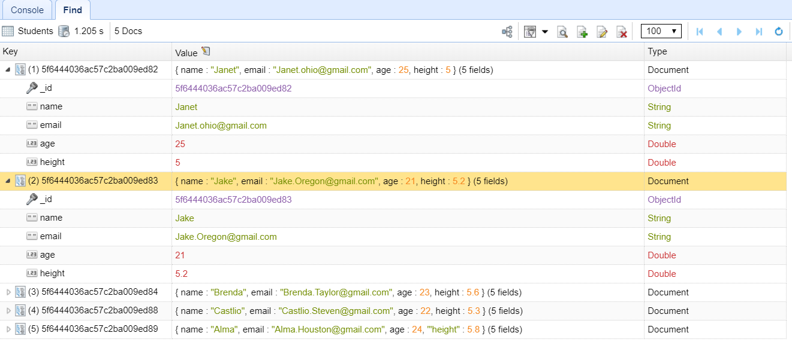

**Find all students whose age is between 21 - 30 and height is greater than 5**

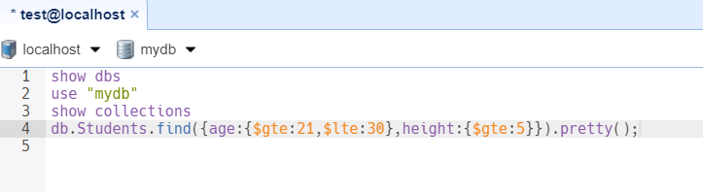

**Result:**

